**Proposal:**

A multiplayer game of 3 cards war (highest card win). There will be a game room for 4 players to join, and real-time updating of player moves. It will be similar structure to the live chess website where you can create a game room or join an existing one. Users will prompted to log in before accessing the lobby. So, each players must create an account before playing.

**How to Play:**

The goal of the game is to get the highest point possible. The lowest point on the card is the ace (1 point). Other cards 2-10 worth its numerical value but jacks are 11, queens are 12. The highest card is the king (13 points). For suits, diamonds are the lowest followed by clubs, hearts, and the highest being spades. The game is turned-based, each player has to wait for their turn and active players will be dealt one card until they have 3 cards. Once every player has 3 cards, each player must select their highest card and player will the highest card will win the game.

**UI Mock-up: (some mock-up are not accurate since the project topic changed)**

Login Page:

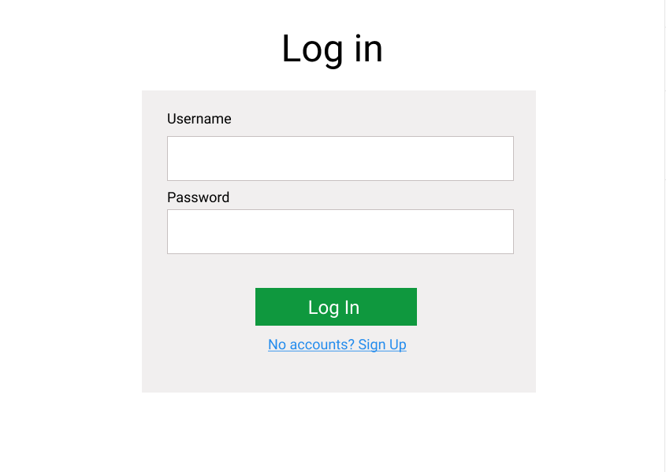

Lobby:

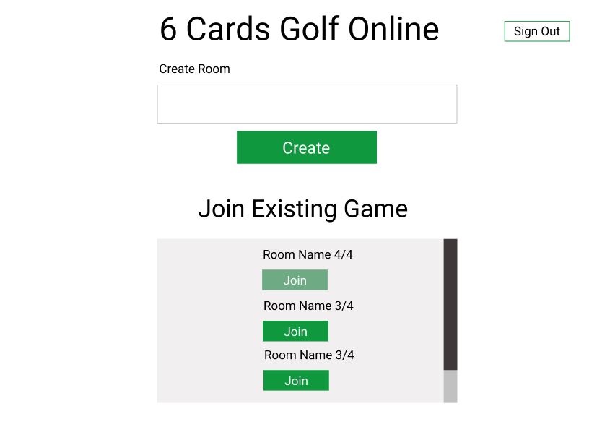

In-Game: “display: flex” will be used for the div

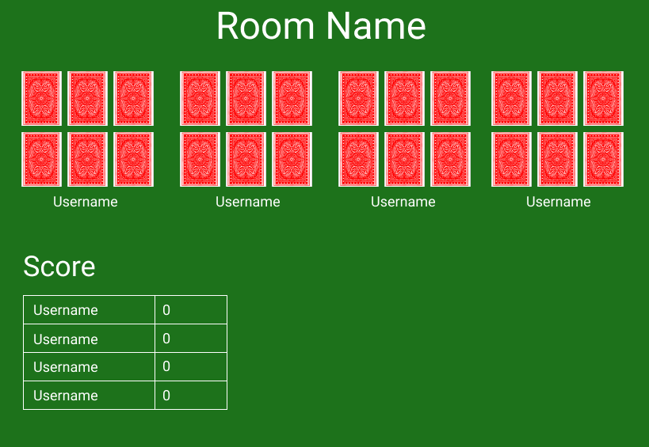

**UML:**

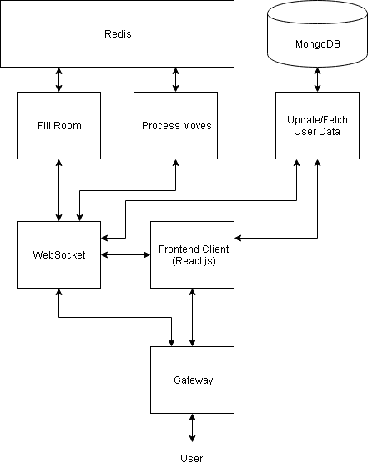

**Architecture:**

* AWS EC2 Server
* Ubuntu 18.04
* MongoDB 4.0
* Node.js 11.13.0
* React.js 16.8.6
* Redux
* Express.js
* Redis 5.0.4
* Kafka
* Docker
* Figma (For UI Mockup)